PUSL2019 – Information Management and Retrieval

Coursework
2022 - 2023

Term: Term 4
Submission Deadline: 23rd January 2023
Coursework Type: Group Assignment (6 members)
Element of Assessment: C1 and P1
Module Leader: Naji Saravanabavan
E-mail: naji@nsbm.ac.lk

1)Introduction

In our supermarket, the shelves are where the products are showed and sold .
Each shelf has an shelf id(we use this shelf id to identify each shelf)
and it belongs to a specific category,

The shelves are stocked with a variety
of products from the supermarket's inventory, which are identified
by a unique product_ID(product id is unique for each and every product)
, product_name, and price.
The products that we are selling in our supermarket
are supplied by various suppliers, who are identified by a unique supplier_id
and company name, we take supplier name for our use of the database and are responsible for providing the supermarket with
a steady stream of goods.

The employees of the supermarket, who are identified
by a unique Empid, Employee name, and job title, are responsible for keeping the
shelves stocked and organized, and they help customers to find the products they
are looking for. Customers, who are identified by a unique customer ID and contact
information, can place orders for products either in person at the store or online, and the
orders are fulfilled using the products from the inventory. The sales made by the supermarket,

which include the date of the sale and the quantity and total price of each product sold, are
recorded and tracked, and the information is used to restock the shelves and manage the inventory.

These are the cardinalities which are found by the above scenario

One shelf can contain multiple products.
One product can be displayed on multiple shelves.
One supplier can supply multiple products.
One product can be supplied by multiple suppliers.

ER diagram

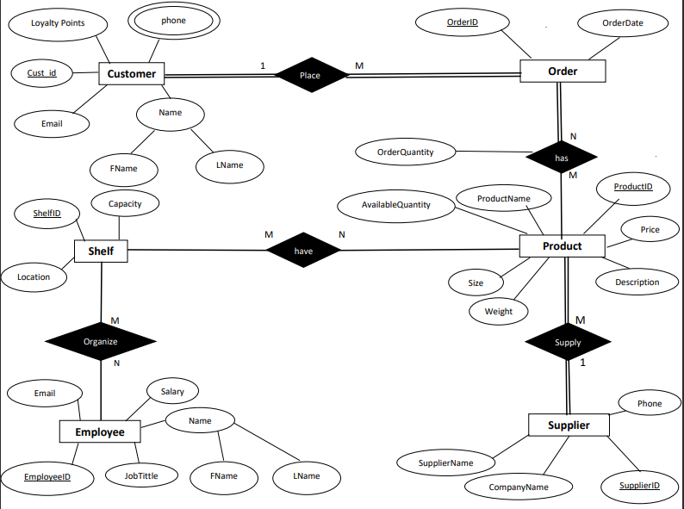

Assumptions

1)There can't be customers without placing any orders.
We only store data about customers who place orders in our supermarket.

2)There can't be orders which are not placed by customers

3)There can be products which are not available in an order

4)There can't be orders without having at least a one product

5)there can be empty shelves without having any product

6)There can be products which are not store in a shelf

7)There can be shelves without organized by employees

8)there can be employees which are not organising the shelves

9)Every product has a supplier

10)Every supplier has a product to supply

11) there can be products which do not contain in sale

Mapping

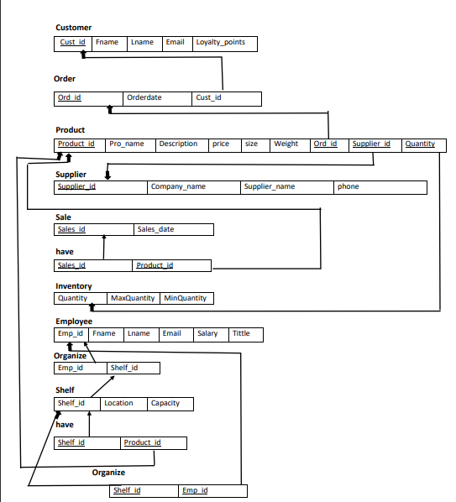
Data Normalization

This all tables are already in 3NF so it’s no need to normalize these tables.

So let’s see why this tables are in 3NF .

So these are the things that we should keep looking when we are normalizing up to 3NF

1))
Every non-primary key column must be functionally dependent on the
primary key. This means that for each value of the primary key, there
is only one possible value for each non-primary key column.

2))
There should be no transitive dependencies among the columns in the table.
This means that non-primary key columns should not be dependent on other
non-primary key columns.

3))
There should be no repeating groups of data.
This means that there should not be multiple sets of data
that are stored in the same table and can be uniquely
identified by a subset of the primary key.

4))
Each table should have only one primary key.

5))
All non-primary key columns should be atomic,
meaning that they should not be able to be further.
divided into smaller pieces of data.

Data Dictionary

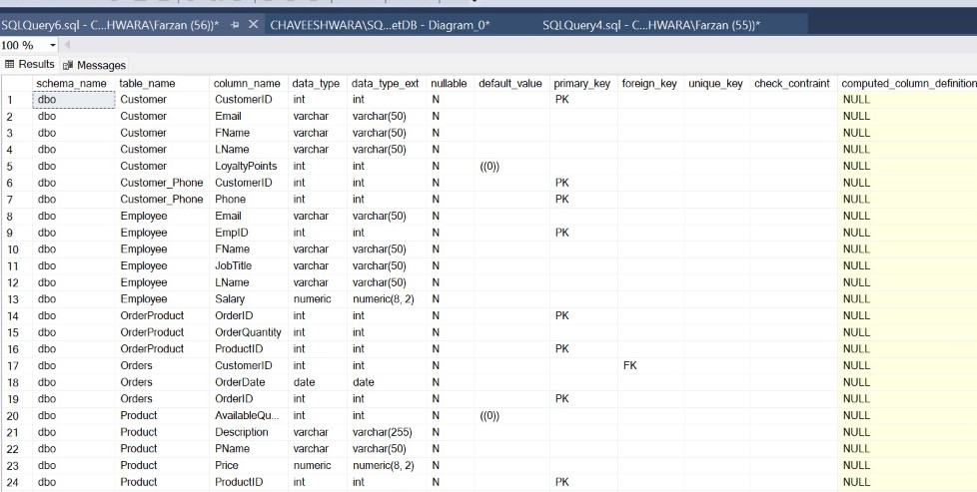

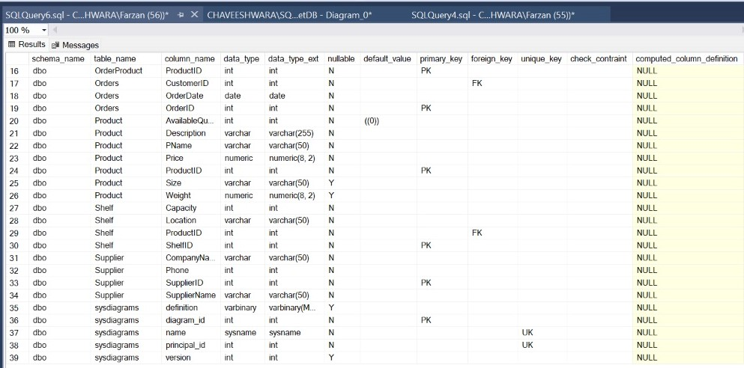

Create Table

Employee table

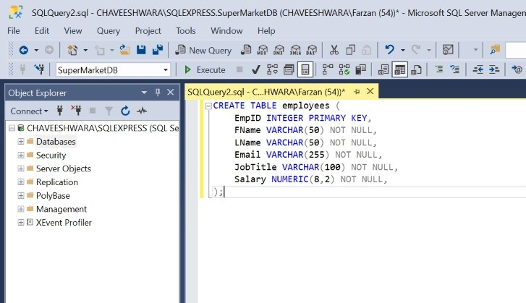

Customer table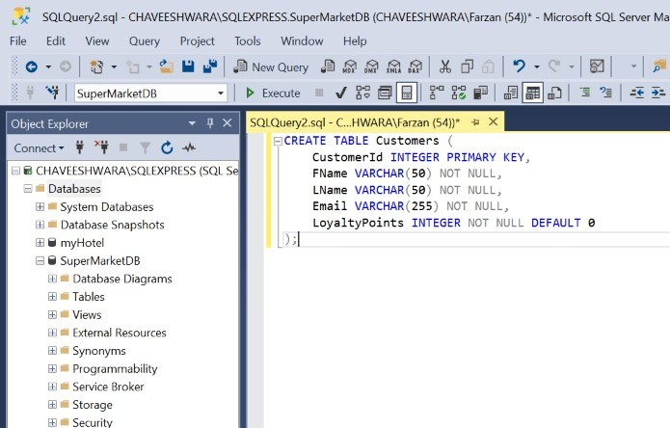

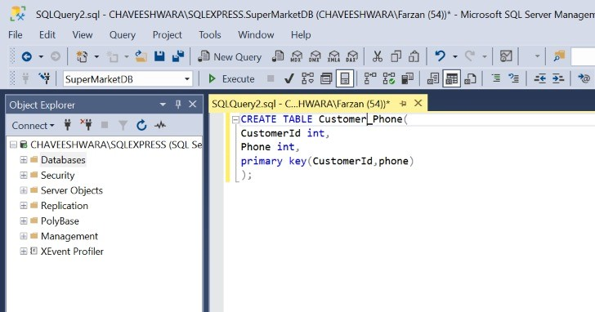
CustomerPhone Table

Order table

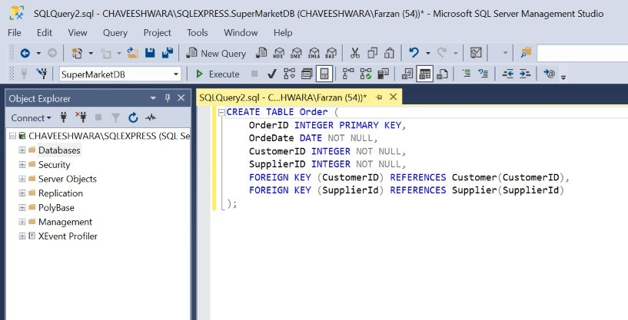

Product table
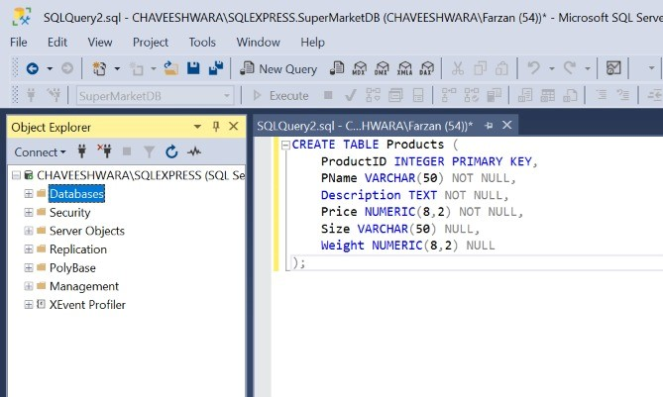

Sale Table

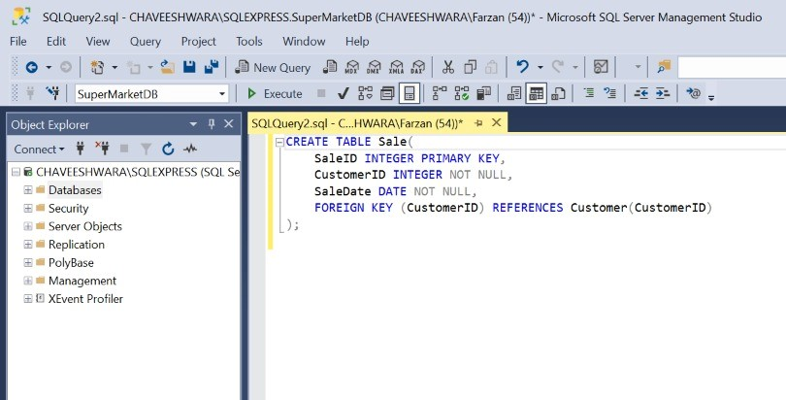

Shelf table

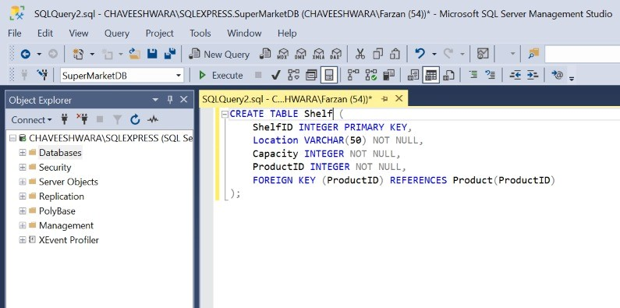

Supplier Table
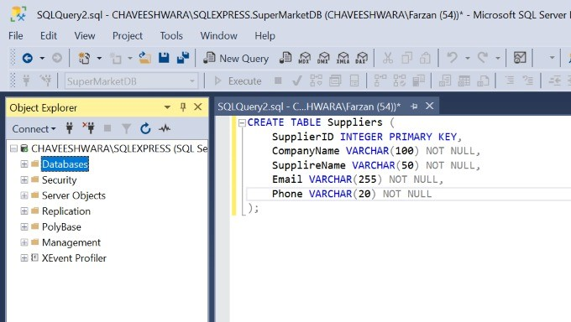

Database Diagram
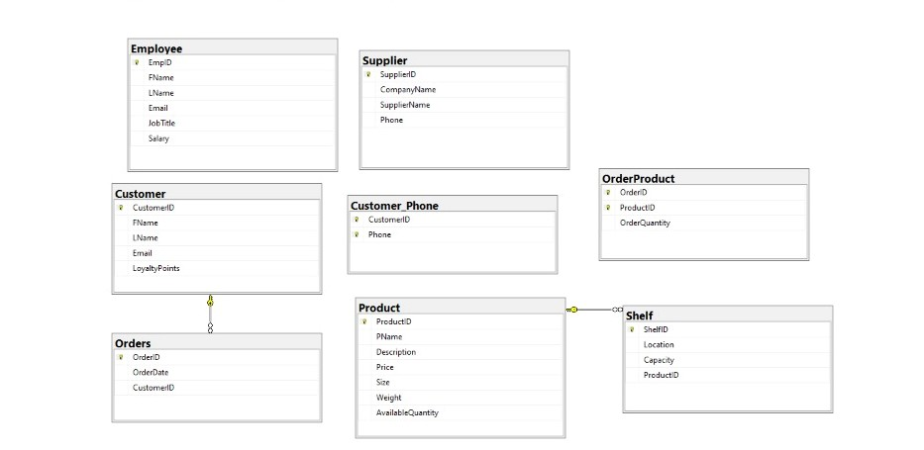

Insertion Tables

CustomerPhone table

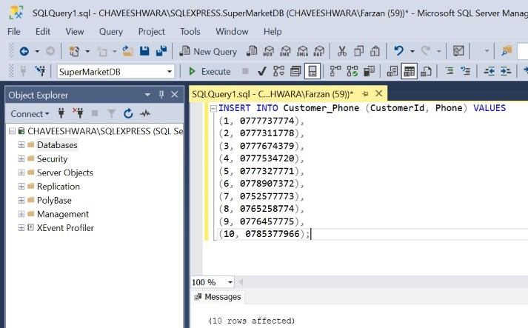

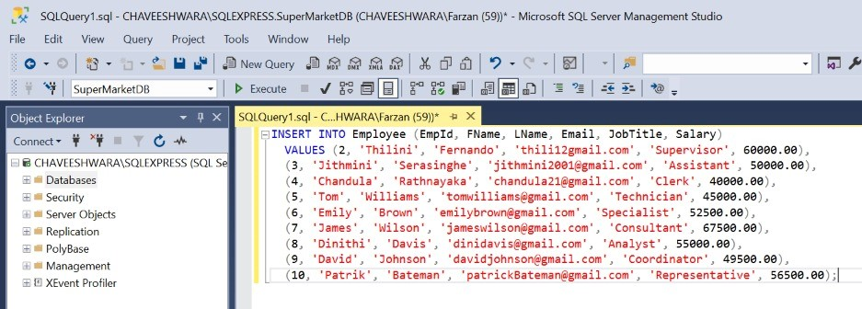
Employee Table

Product table

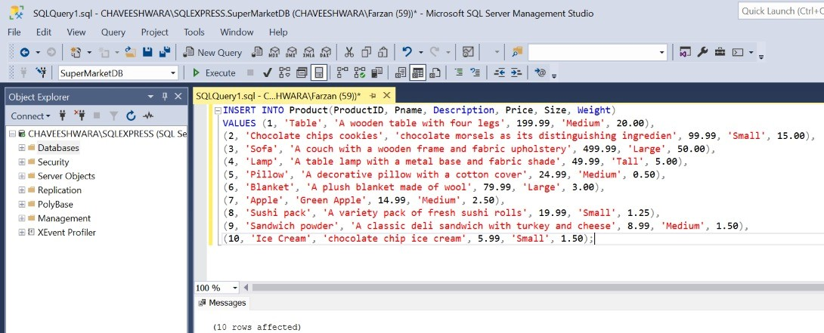

Shelf table
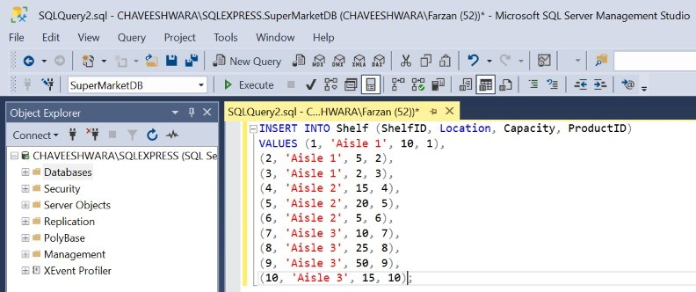

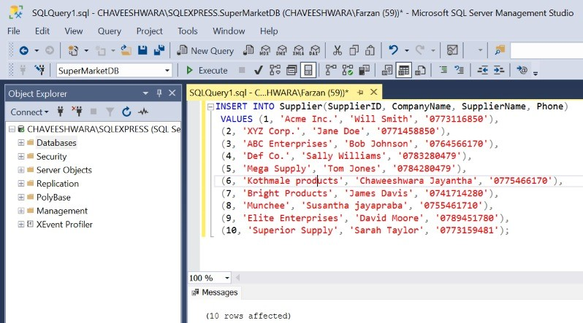
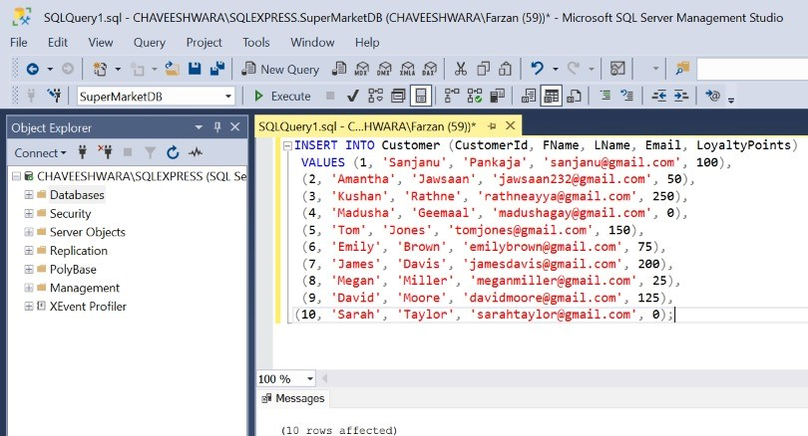
Supplier table

Customer Table

Triggers

Trigger 1

CREATE TRIGGER update_loyalty_points
ON Orders
AFTER INSERT
AS
BEGIN
UPDATE Customer
SET LoyaltyPoints=LoyaltyPoints +1
WHERE customerid =( SELECT CustomerID FROM inserted)
END;

this trigger will update the Loyaltypoints of a customer.
We have to select the customer_id.

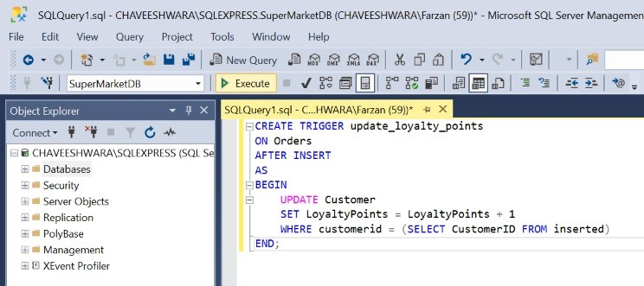

Before the query executed (Customer tableLoyalty points column)

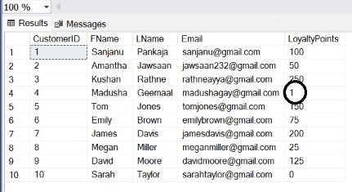

After the query got executed (Customer table Loyalty points column)

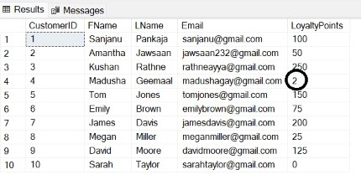

Functions

Function 01

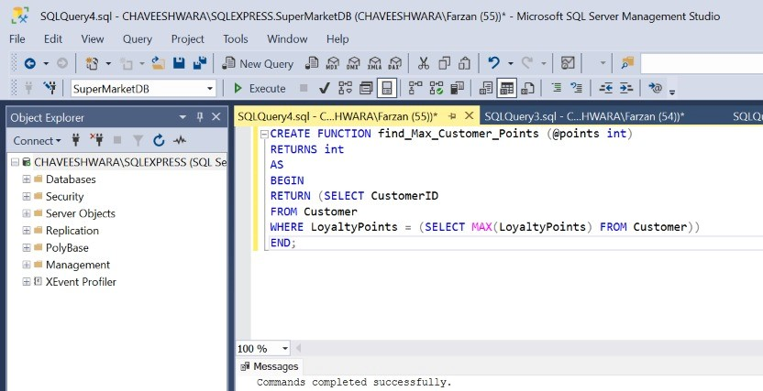

CREATE FUNCTION find_Max_Customer_Points (@points int)
RETURNS int
AS
BEGIN
RETURN (SELECT Customer ID
FROM Customer
WHERE LoyaltyPoints=(SELECT MAX(LoyaltyPoints) FROM Customer))
END;

This function will find the maximum number of Loyalty points from the Customer table

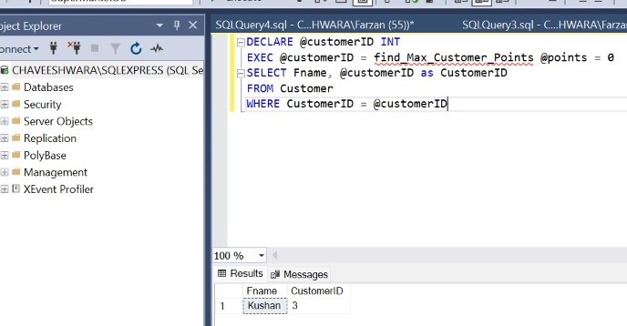

Function 2

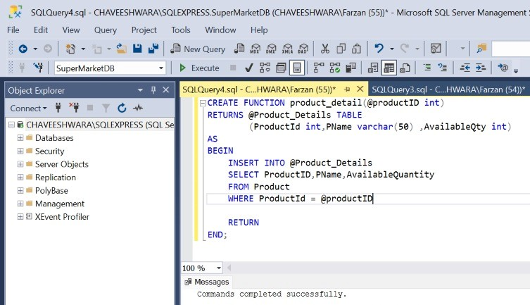

This product_details function will select productid,Pname and AvailableQuantity

Display the function executing

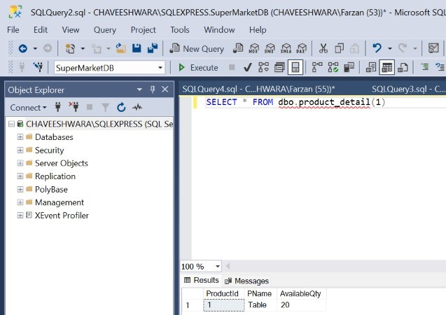

Function 3

This function is used to return the data as a table
This function will return all the fields which are available in the

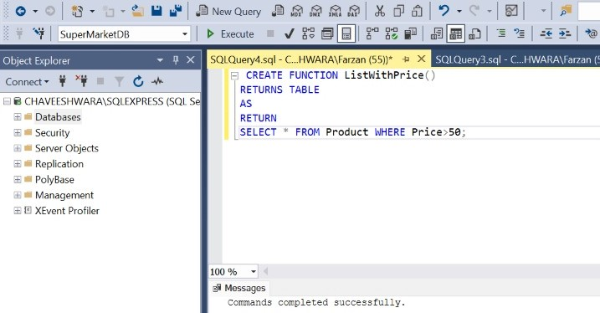

Function 3 execution

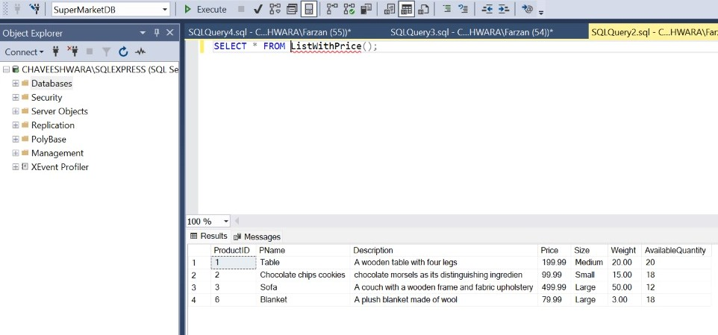

Views

View1

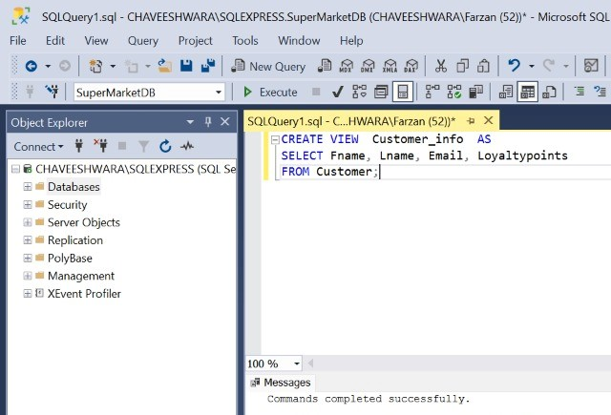

This view will display Fname,Lname ,Email and Loyaltypoints

View 2

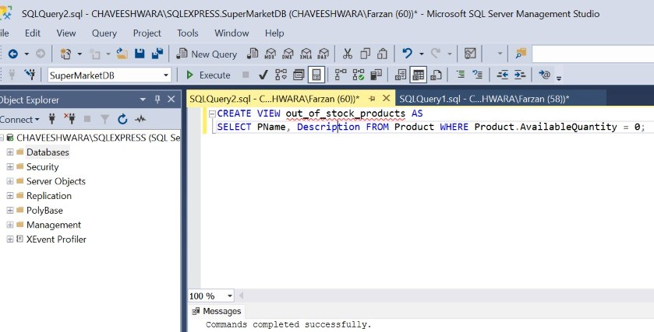

Out_of_product will display the products that are available quantity is 0.

Display the out_of_stock view?
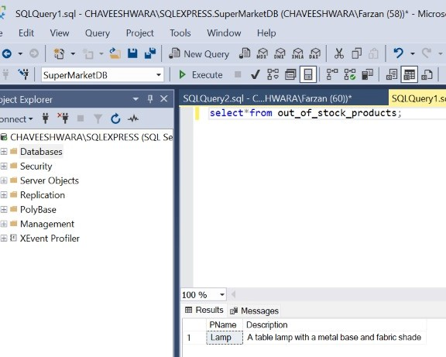

View 3

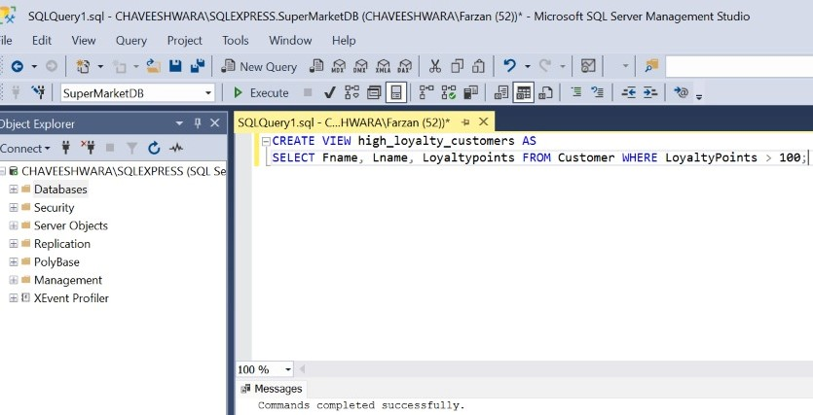

This will display the name and loyaltipoints of customers who have the loyaltypoints higher than 100

View 3 displaying

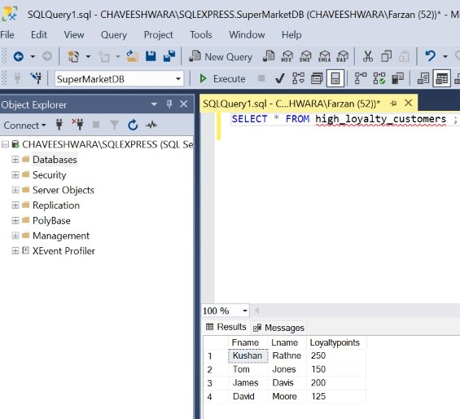

Procedures

Procedure 1

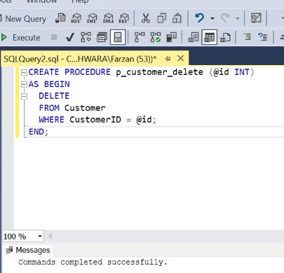

This procedure will delete the customer table row when enter the customer id

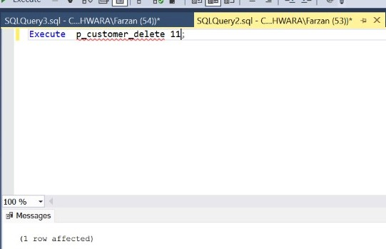

This is the execution of the procedure.

Before executing this procedure ,this will be the view of Customer table

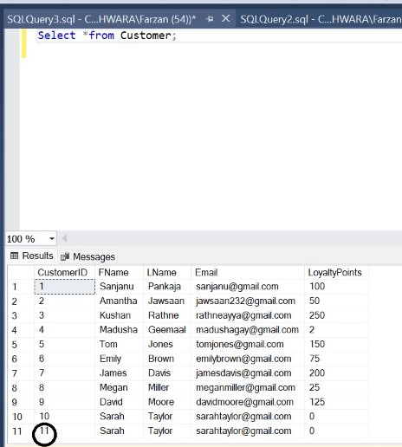

Now after the procedure execute then the Customer table would be like this

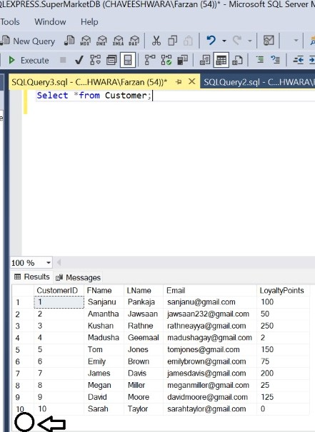

Procedure 2

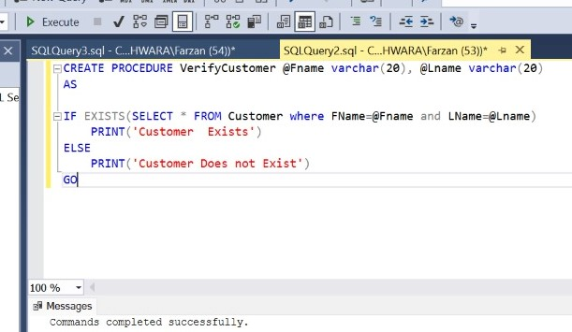

Execute this procedure

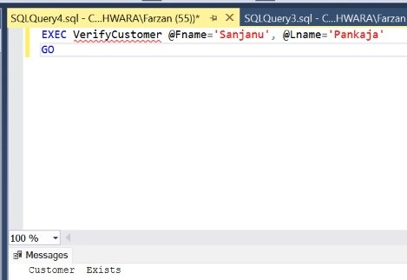

Procedure 3

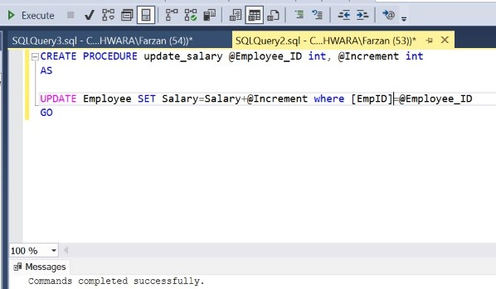

This procedure will update the Salary Column of a Employee So when executing this you have to add the parameters which are needed.

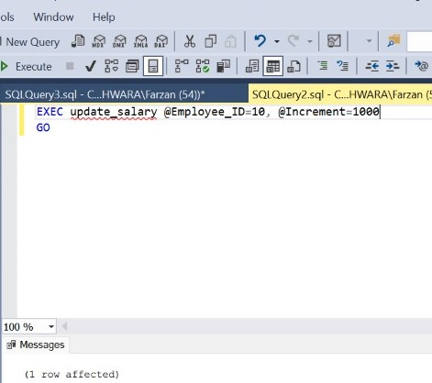

So before this update Salary procedure get execute this is the view

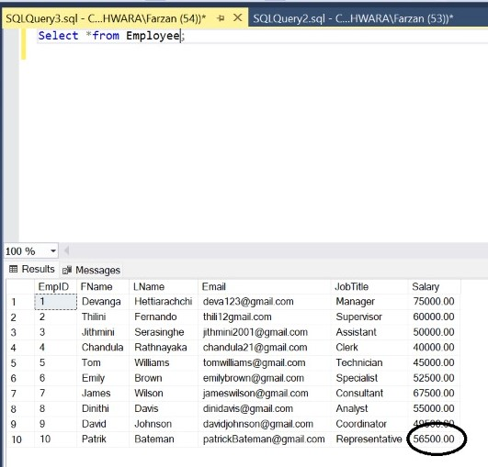

After the Update procedure get called

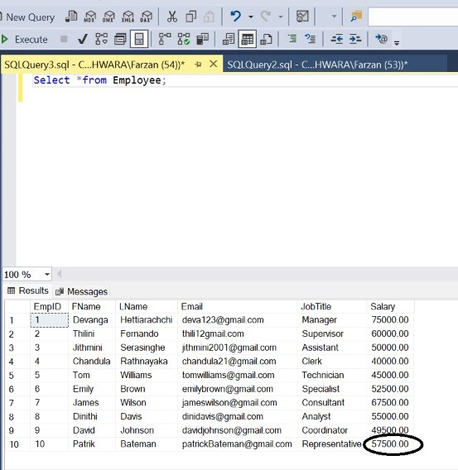

Section 04

Future implementation

Future implementation for this supermarket database could include:

1)We can track the products quantity in our inventory ..so each and every product has a
special place in the inventory so it would be easy to arrange shelves and it whould be easy to
check which products we have to buy.

2)To impove the promotion we should include tables Promotions and sales table to track the
discount ,special offers used to create to give customers more offers and in future our
supermarket will be more productive for customers.

3)If we maintain a customer purchse history record then we can give some special offers to the customers
who have the longest customer history and give some inspiration for them to make there shopping
experience better.

4)If we can track the employees performance something like if we can give points to the
quality of there work and covering targets then it would be great to the development of the supermarket

5)A table to track the popularity of products,
which can be used to inform purchasing decisions and improve product offerings.

6) If we can make an Mobile application to facilitate online ordering then it would be a good chance
to make our supermarket better.

